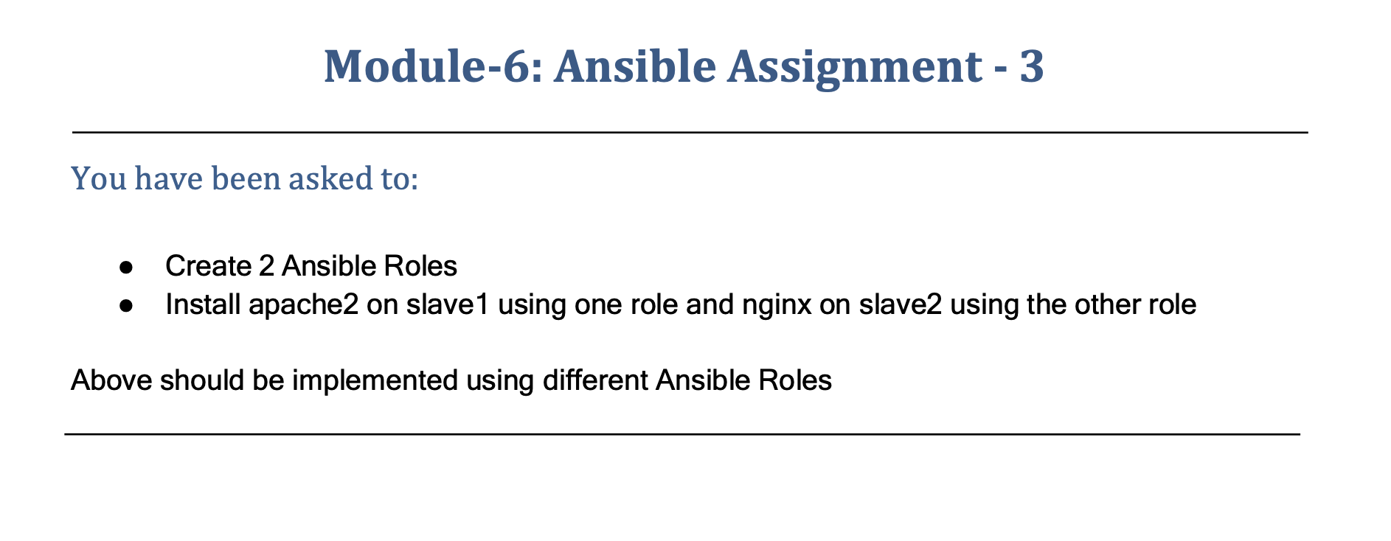

You have been asked to:

● Create 2 Ansible Roles

● Install apache2 on slave1 using one role and nginx on slave2 using the other role

Above should be implemented using different Ansible Roles

**ASSIGNMENT 3**

**Follow the steps:**

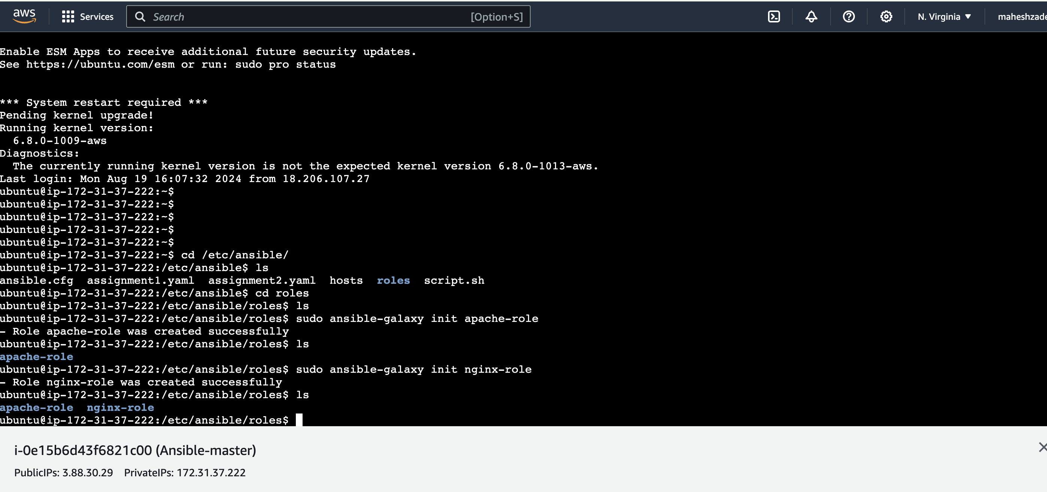

**Run the below commands**

**u** **buntu@ip-172-31-37-222:~$ cd /etc/ansible/**

**ubuntu@ip-172-31-37-222:/etc/ansible$ ls**

**ansible.cfg assignment1.yaml assignment2.yaml hosts roles script.sh**

**ubuntu@ip-172-31-37-222:/etc/ansible$ cd roles**

**ubuntu@ip-172-31-37-222:/etc/ansible/roles$ ls**

**ubuntu@ip-172-31-37-222:/etc/ansible/roles$ sudo ansible-galaxy init apache-role**

**- Role apache-role was created successfully**

**ubuntu@ip-172-31-37-222:/etc/ansible/roles$ ls**

**apache-role**

**ubuntu@ip-172-31-37-222:/etc/ansible/roles$ sudo ansible-galaxy init nginx-role**

**- Role nginx-role was created successfully**

**ubuntu@ip-172-31-37-222:/etc/ansible/roles$ ls**

**apache-role nginx-role**

ubuntu@ip-172-31-37-222:/etc/ansible/roles$ sudo apt install tree

ubuntu@ip-172-31-37-222:/etc/ansible/roles$ ls

apache-role nginx-role

ubuntu@ip-172-31-37-222:/etc/ansible/roles$

ubuntu@ip-172-31-37-222:/etc/ansible/roles$ tree apache-role/

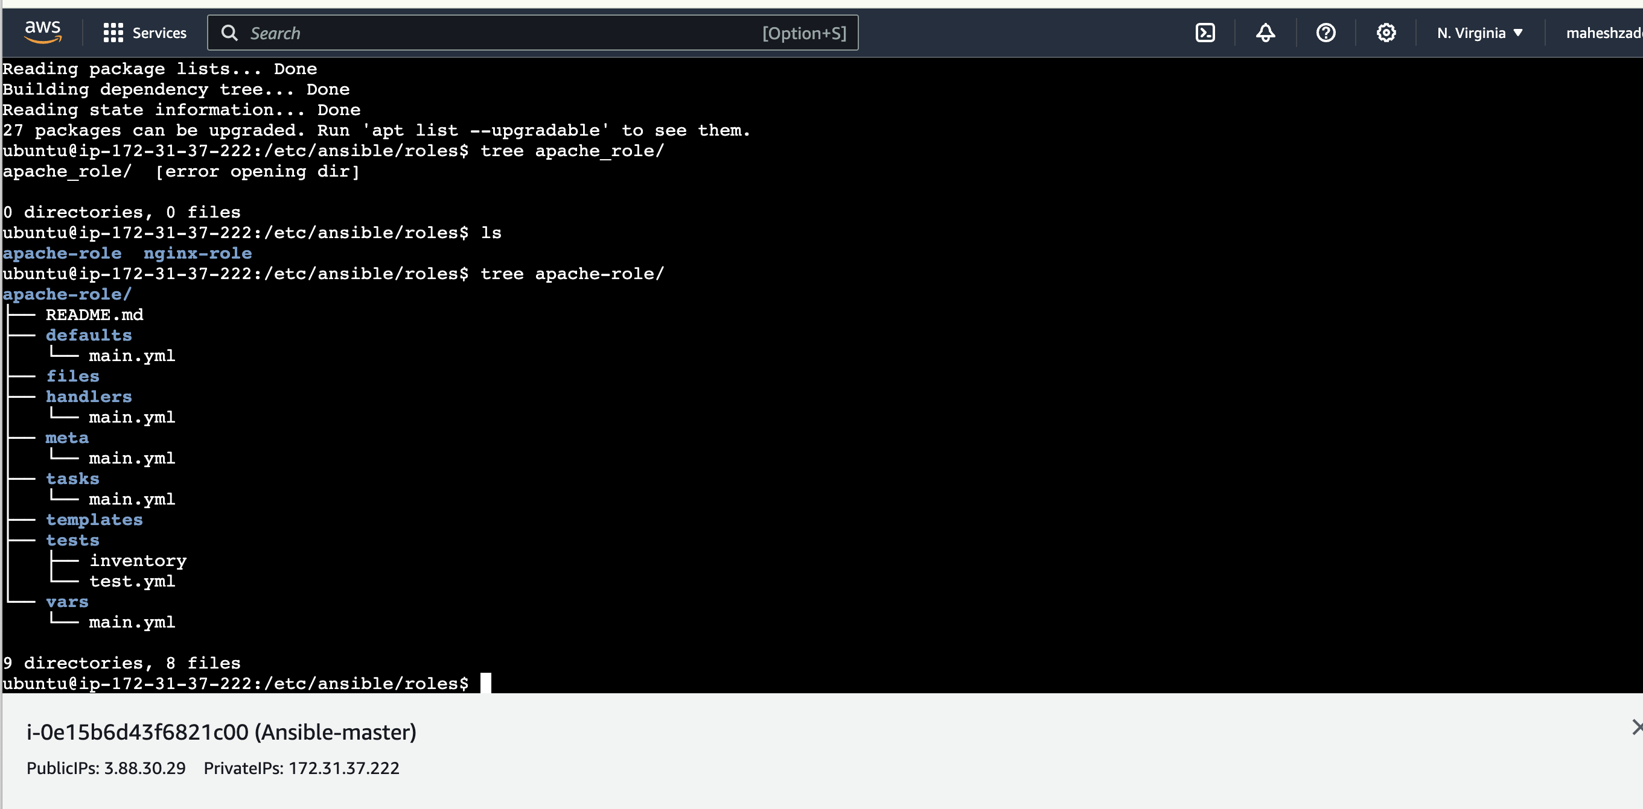

Now go to below path where we are going to install apache

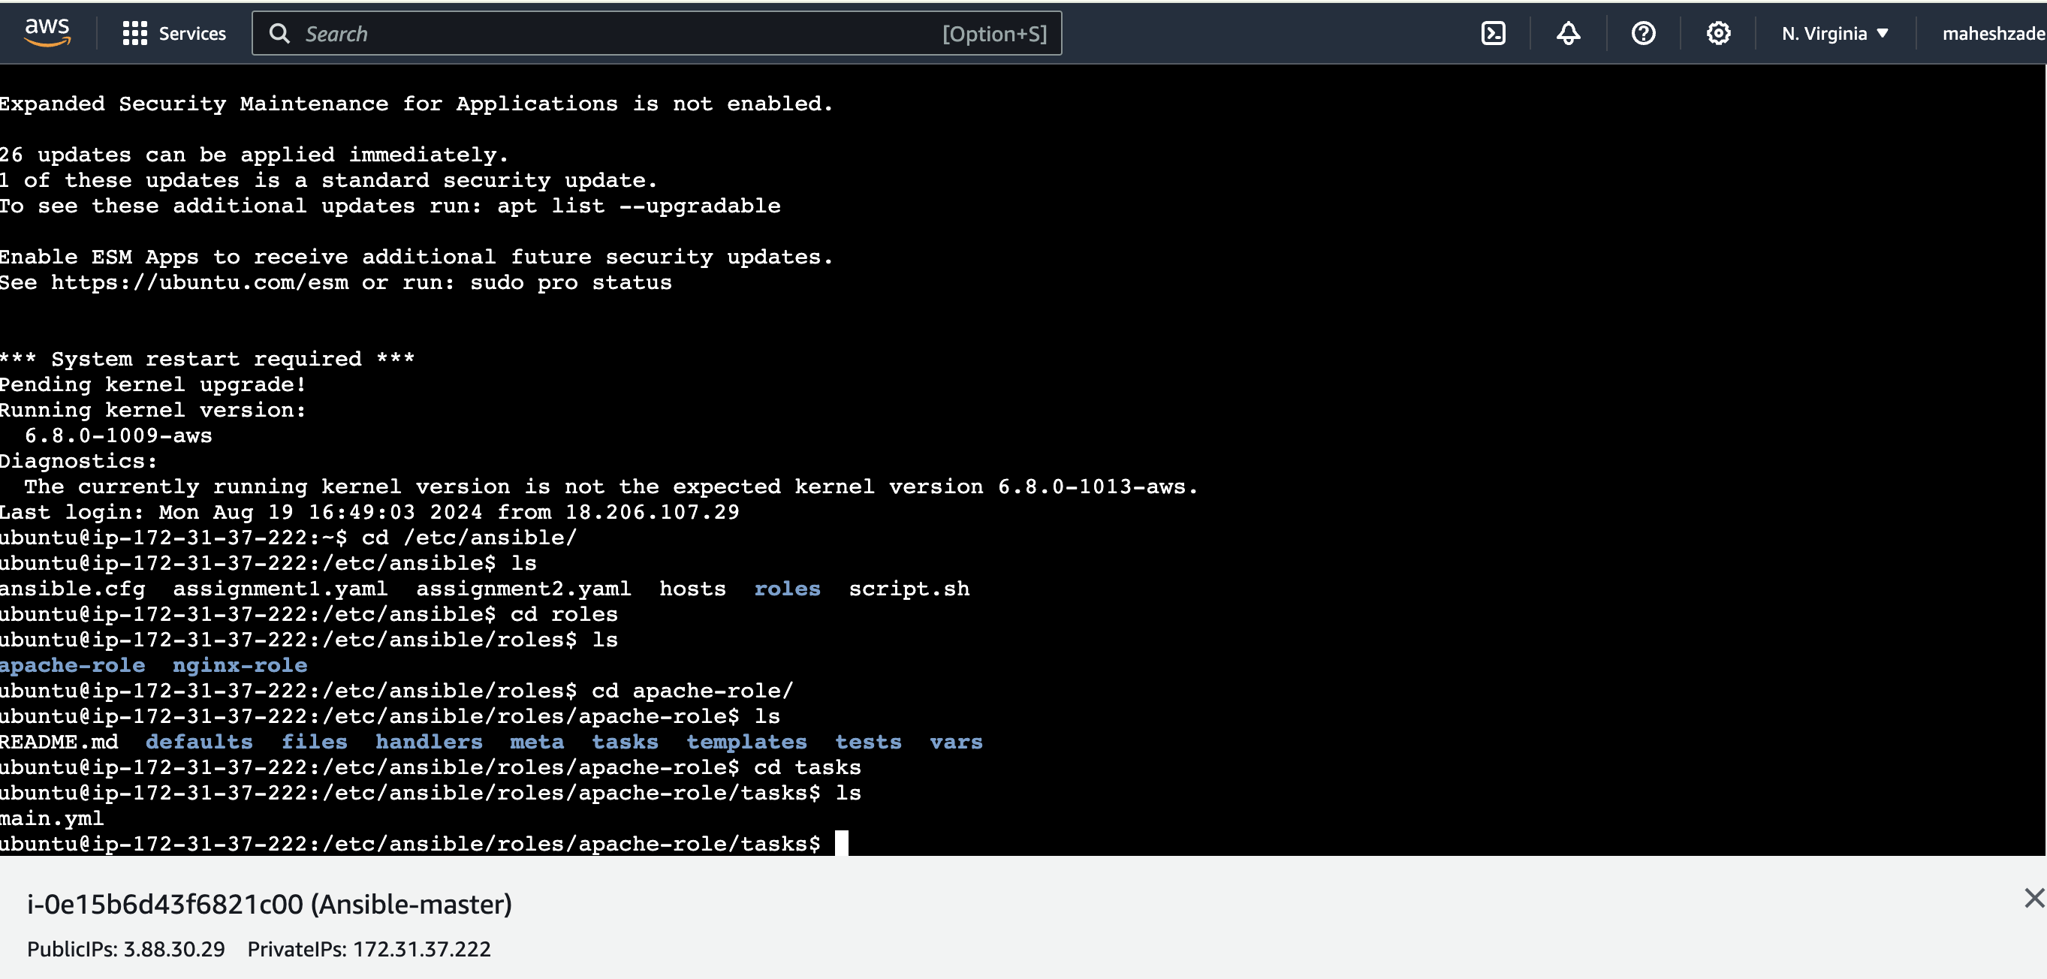

**ubuntu@ip-172-31-37-222:/etc/ansible/roles/apache-role/tasks$ sudo nano install.yaml**

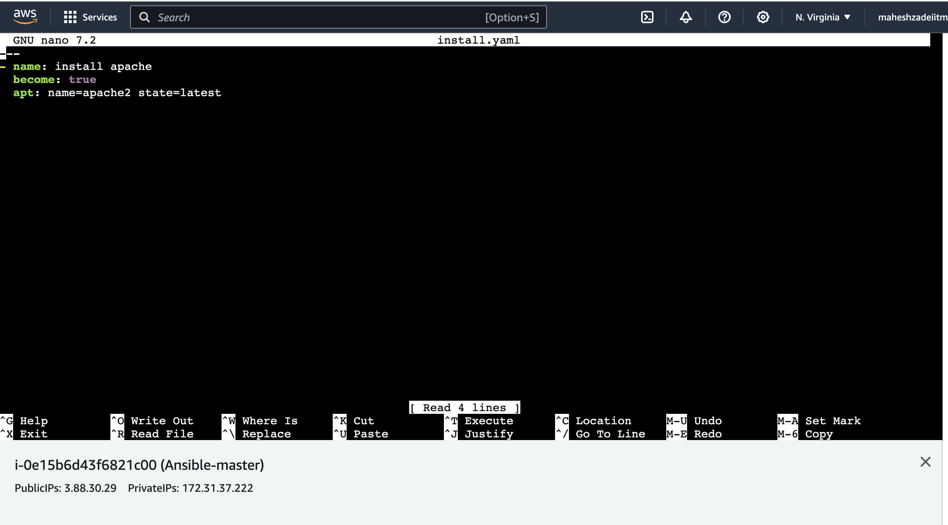

**Save and exit**

**Do ls**

**ubuntu@ip-172-31-37-222:/etc/ansible/roles/apache-role/tasks$ ls**

**install.yaml main.yml**

**sudo nano main.yml**

**make the entry**

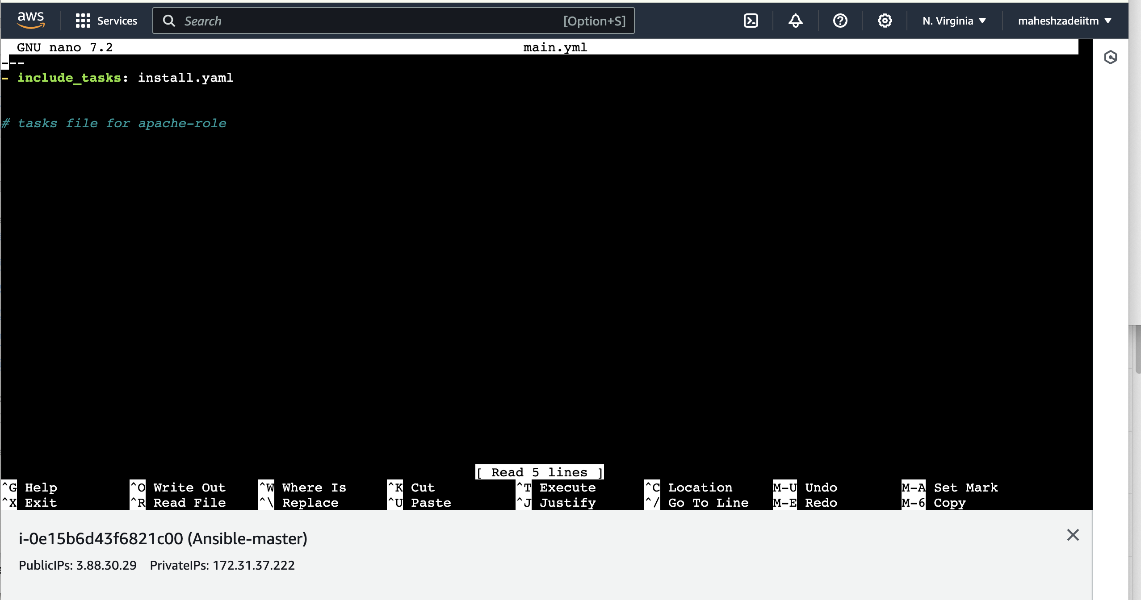

**Save**

**Now create the same for nginx roles**

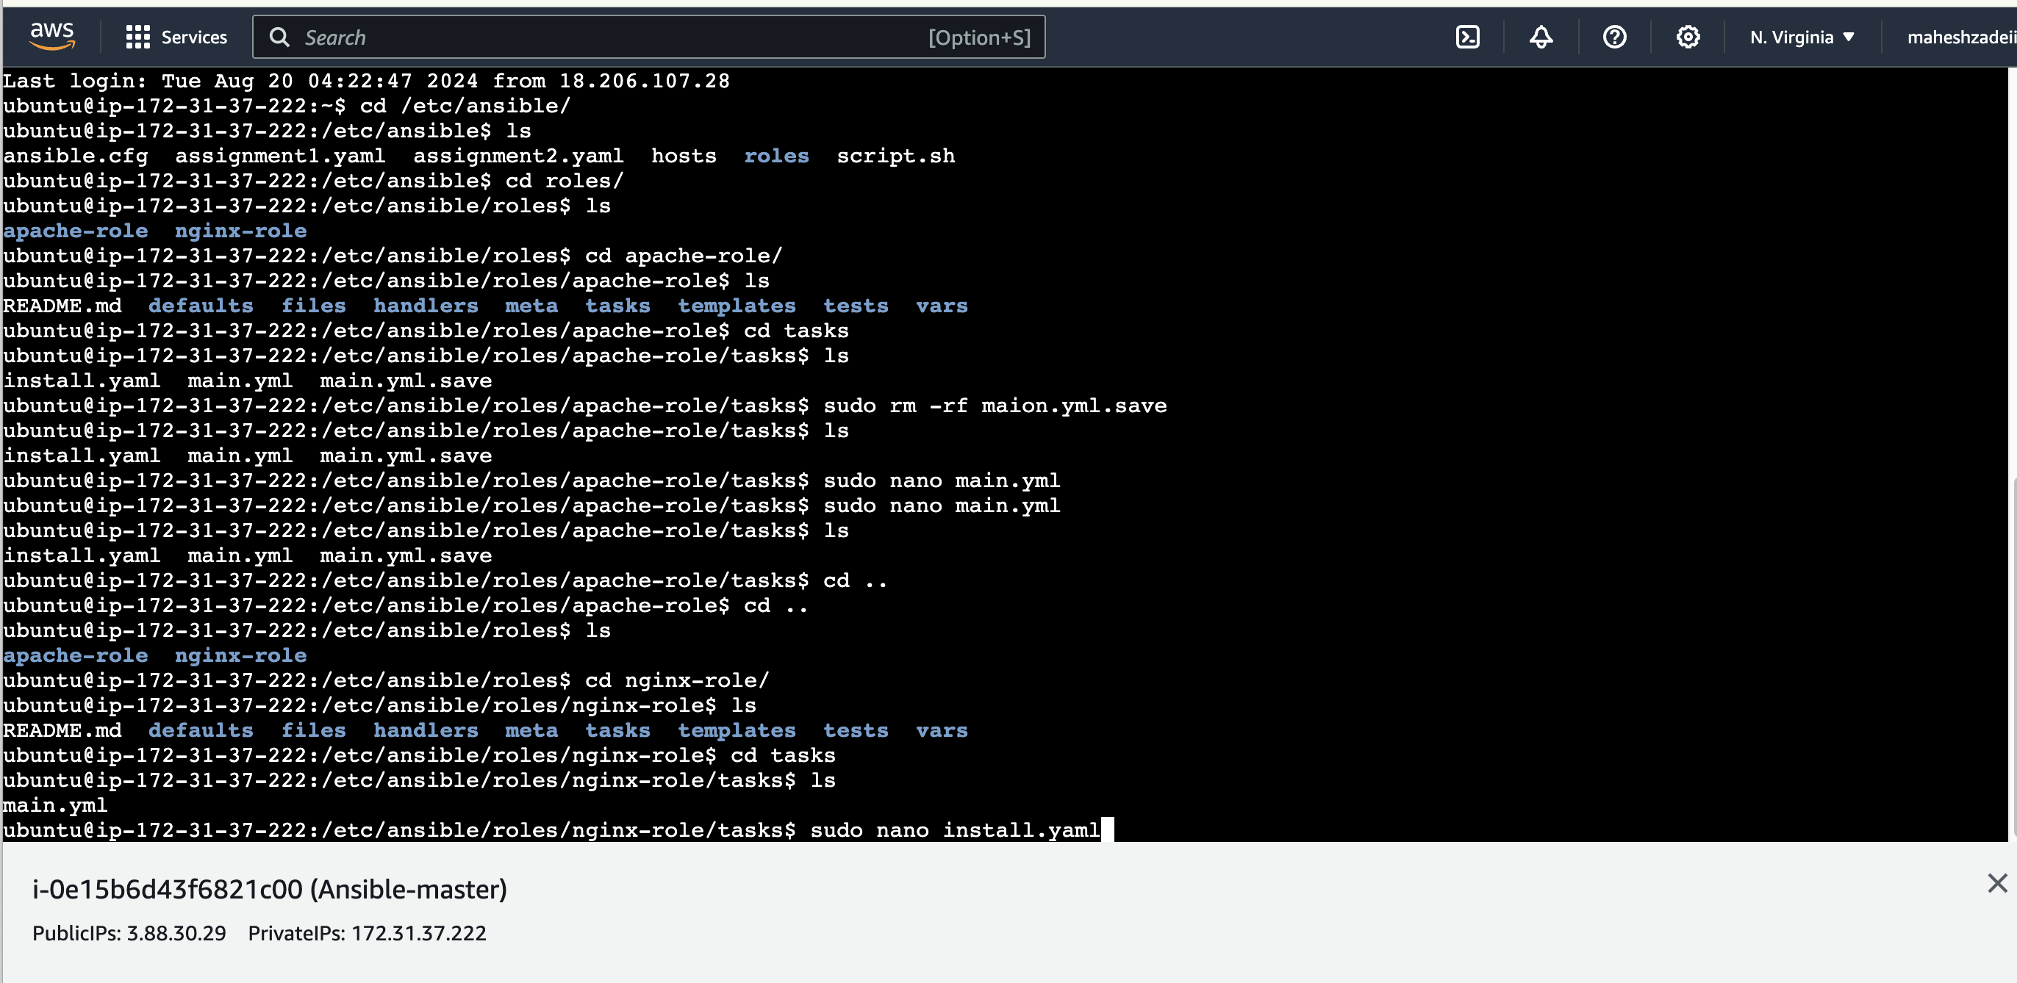

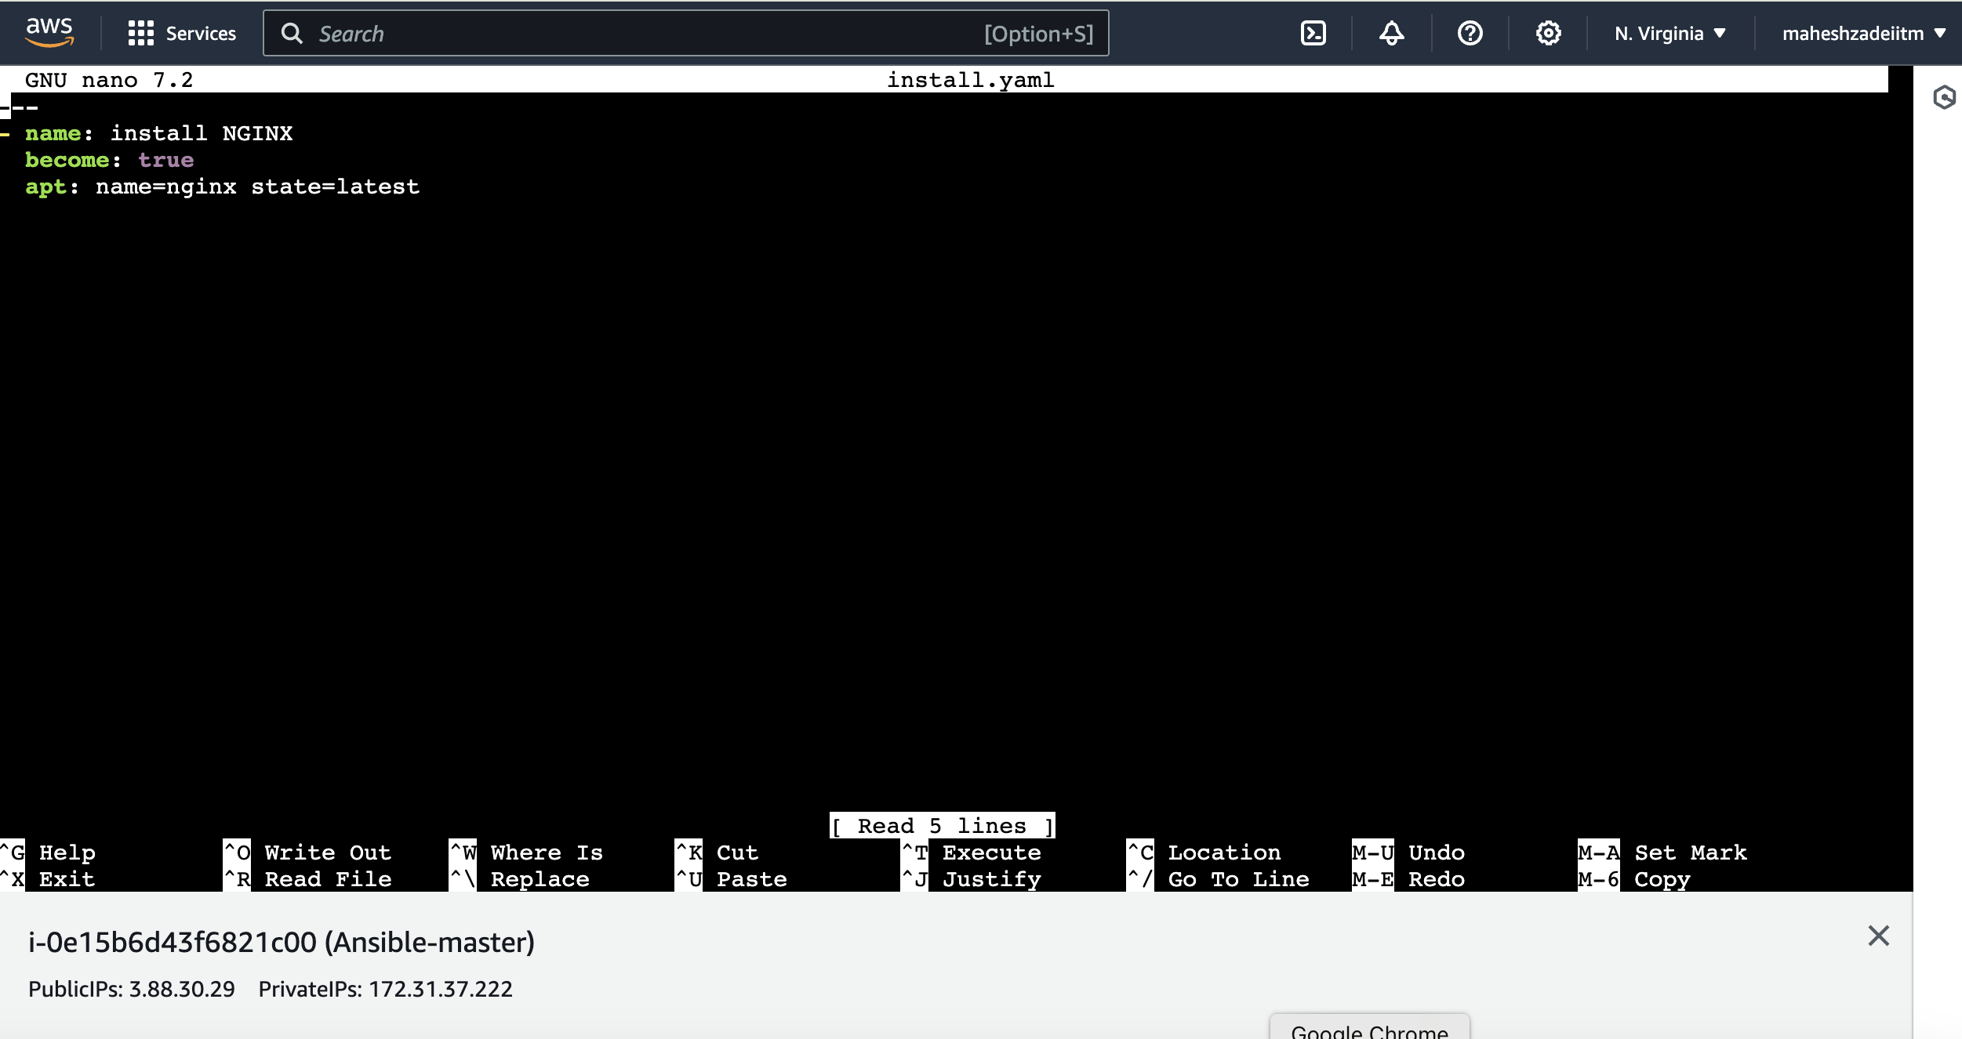

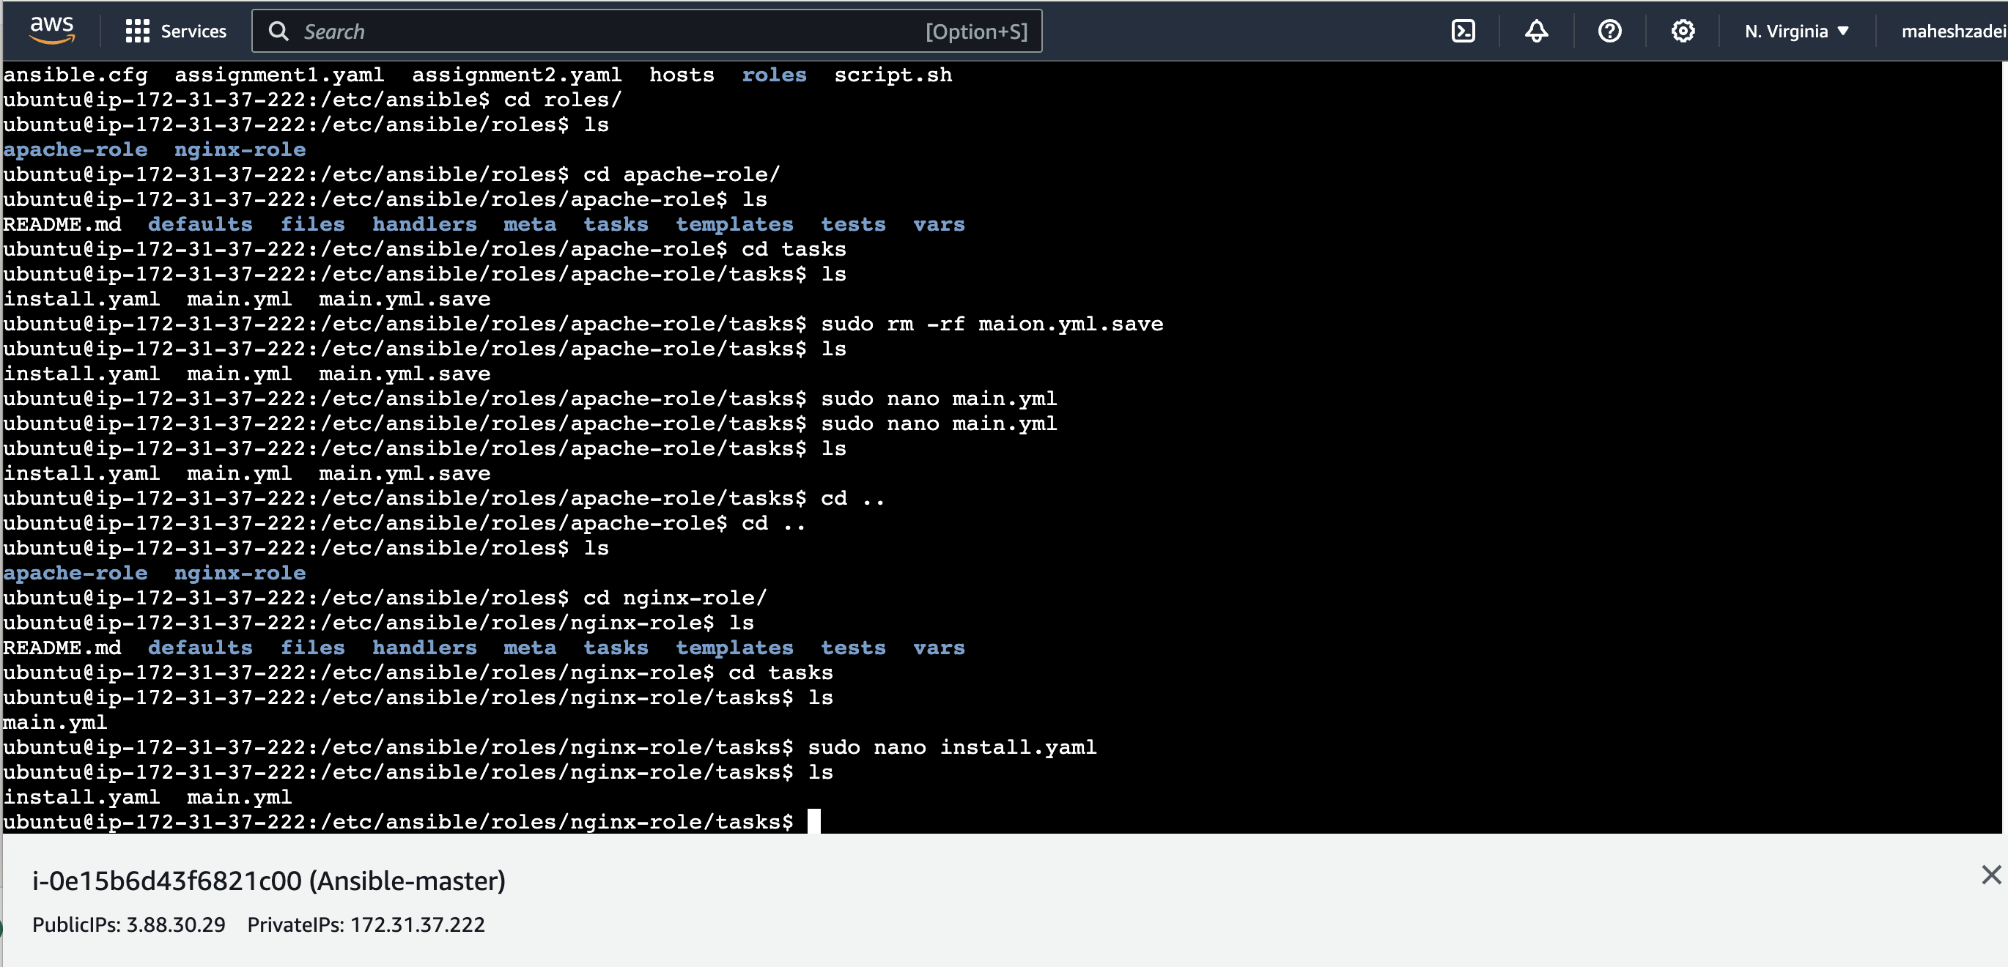

**Now go to**

**Sudo nano main.yml**

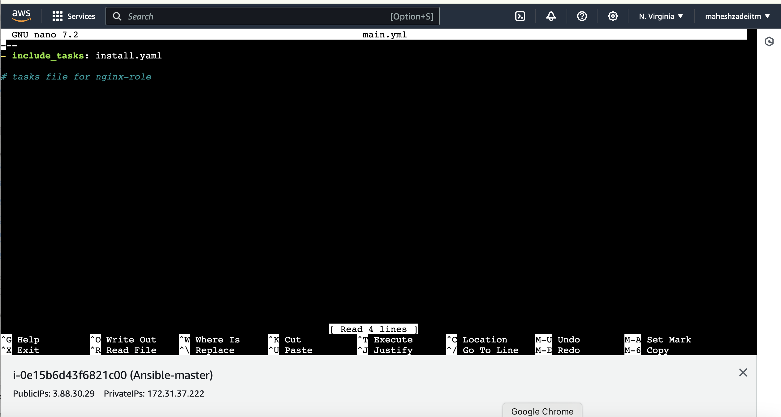

**Save it**

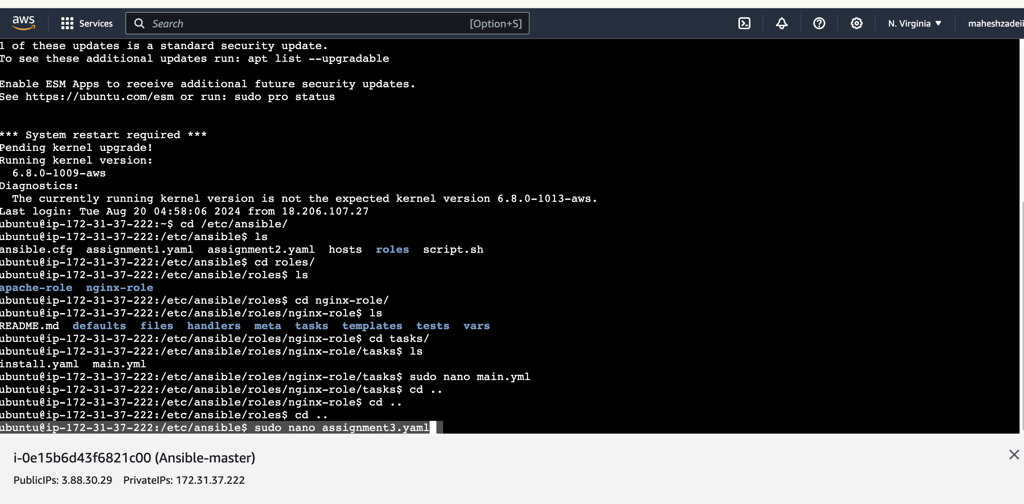

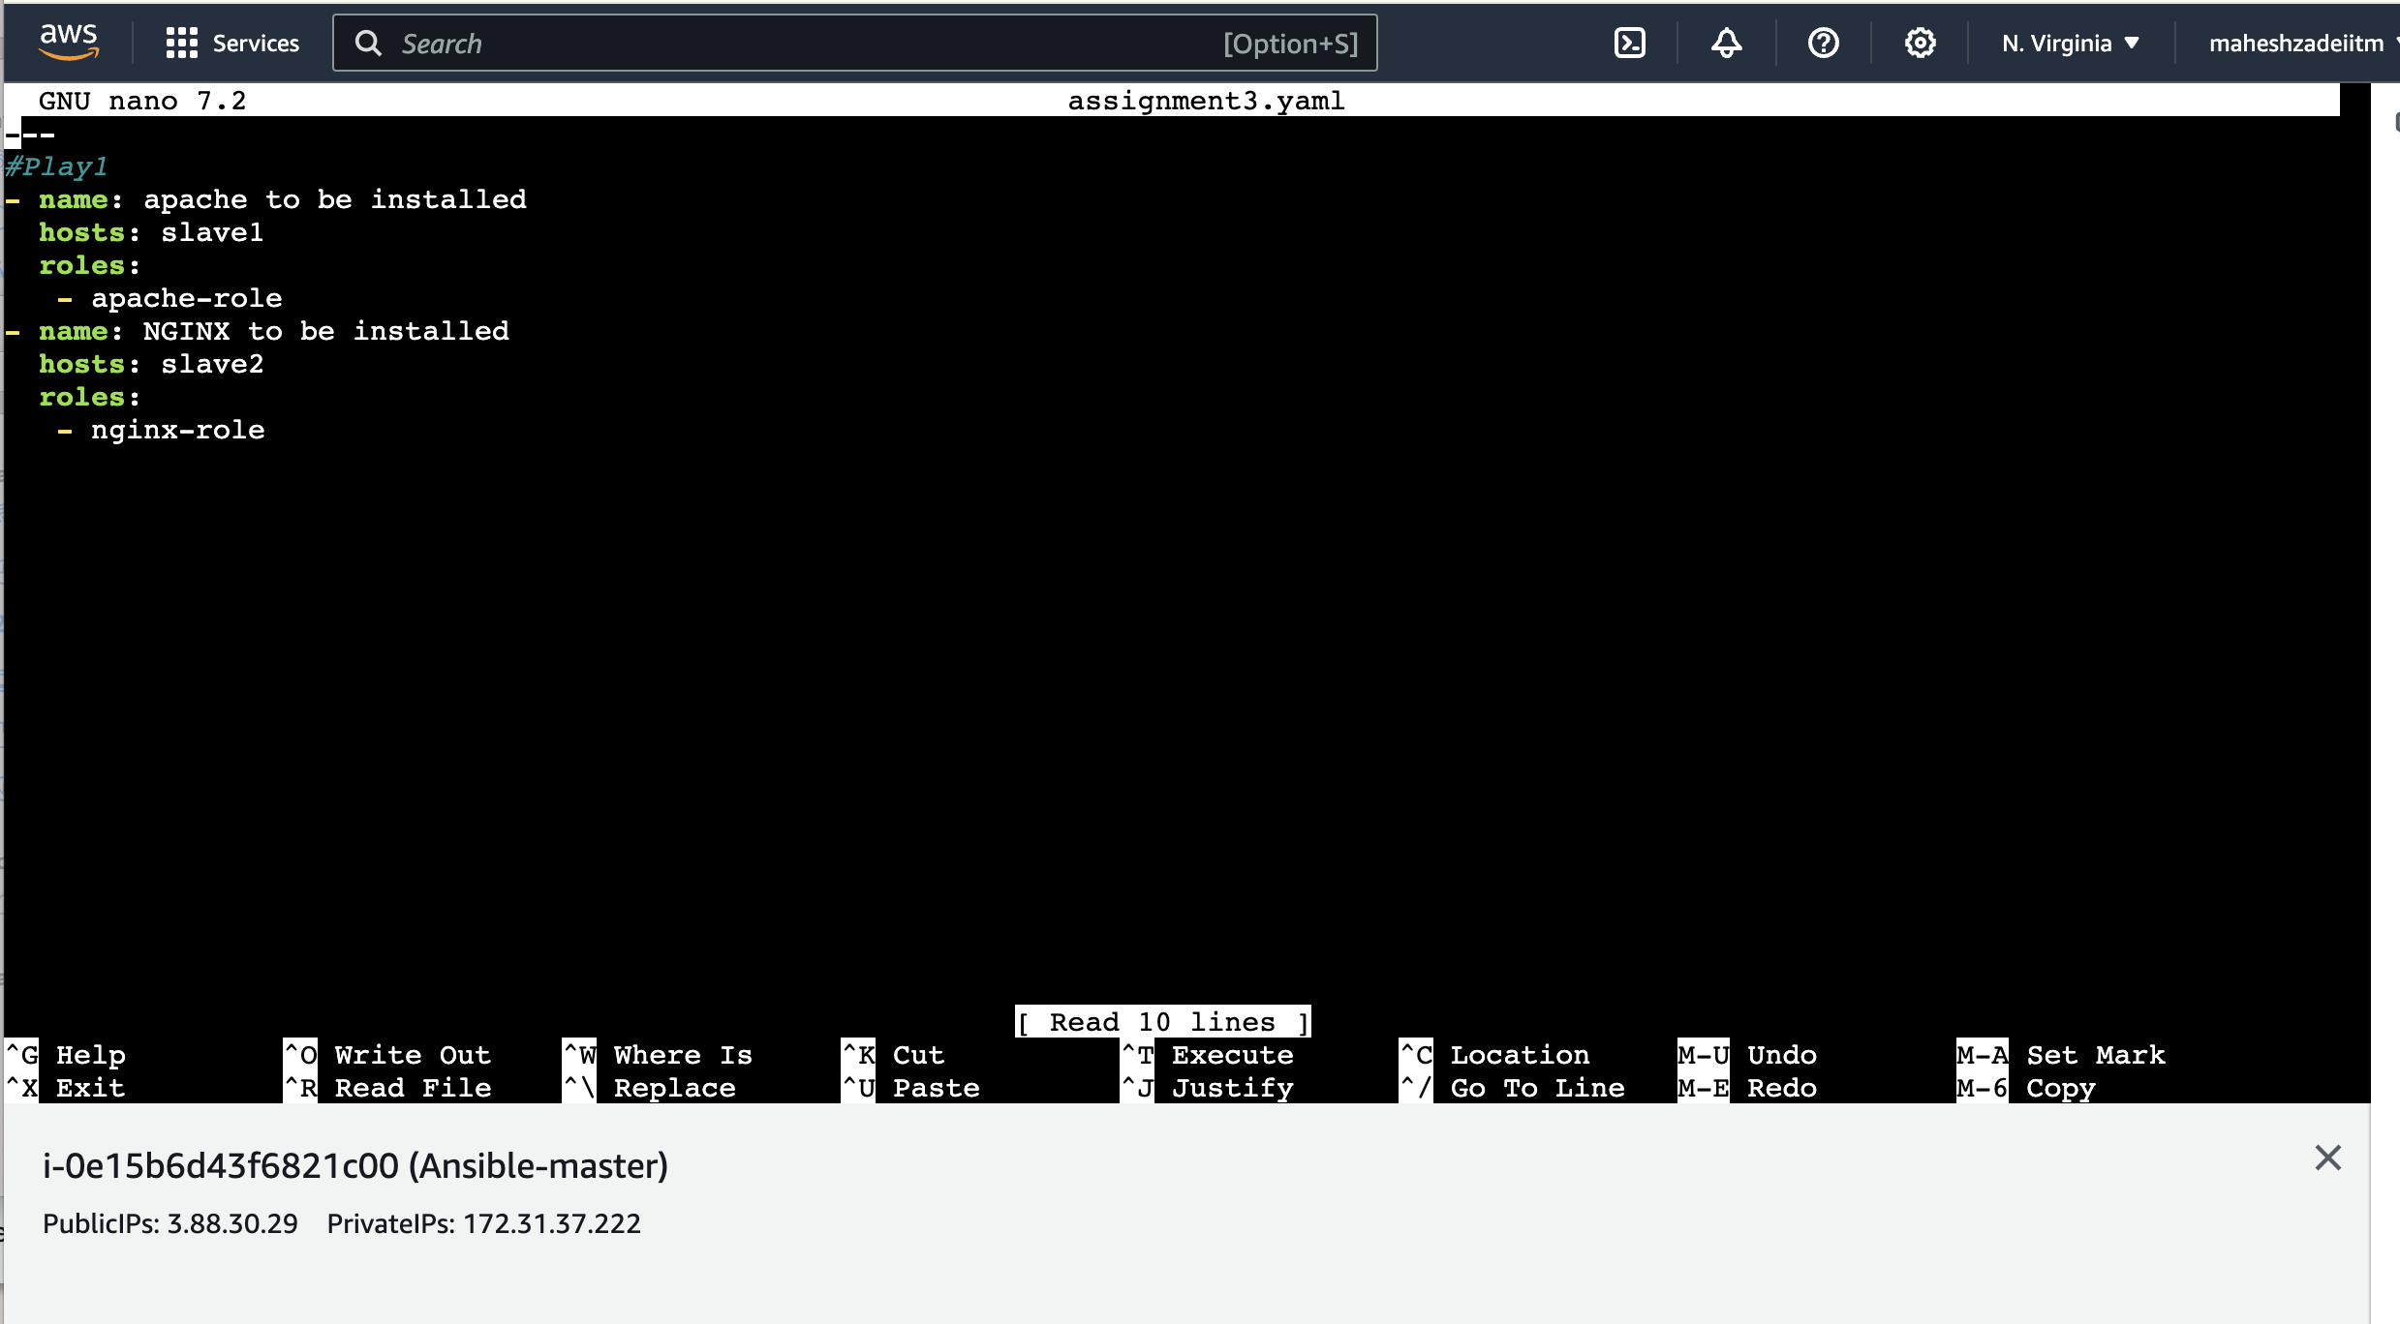

**Architecture as per below**

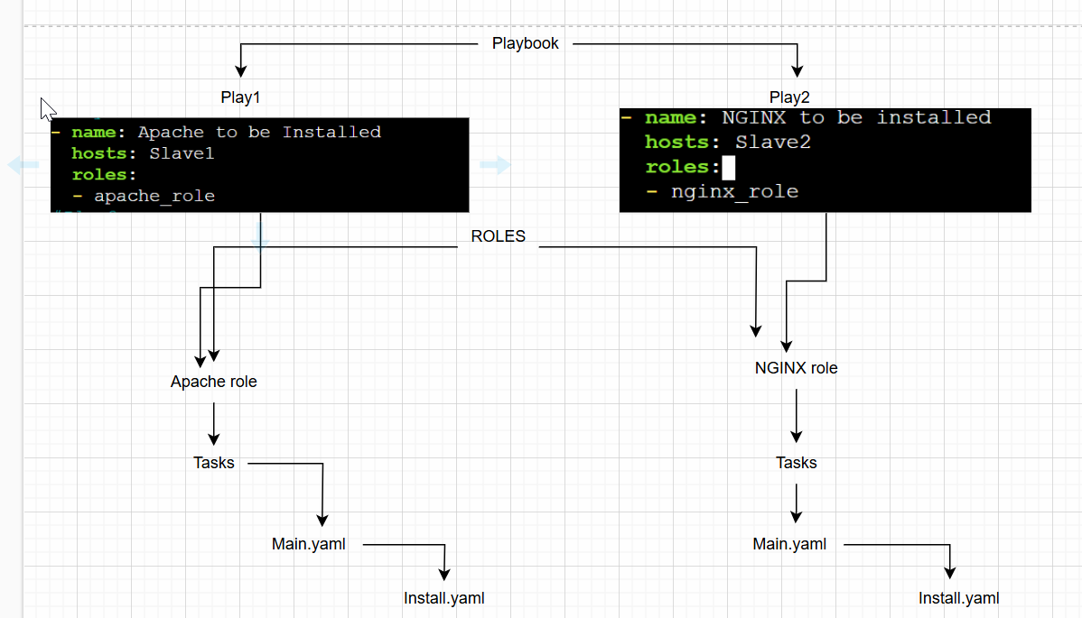

**Install.yaml under apache role:**

**RUN THE PLAYBOOK.**

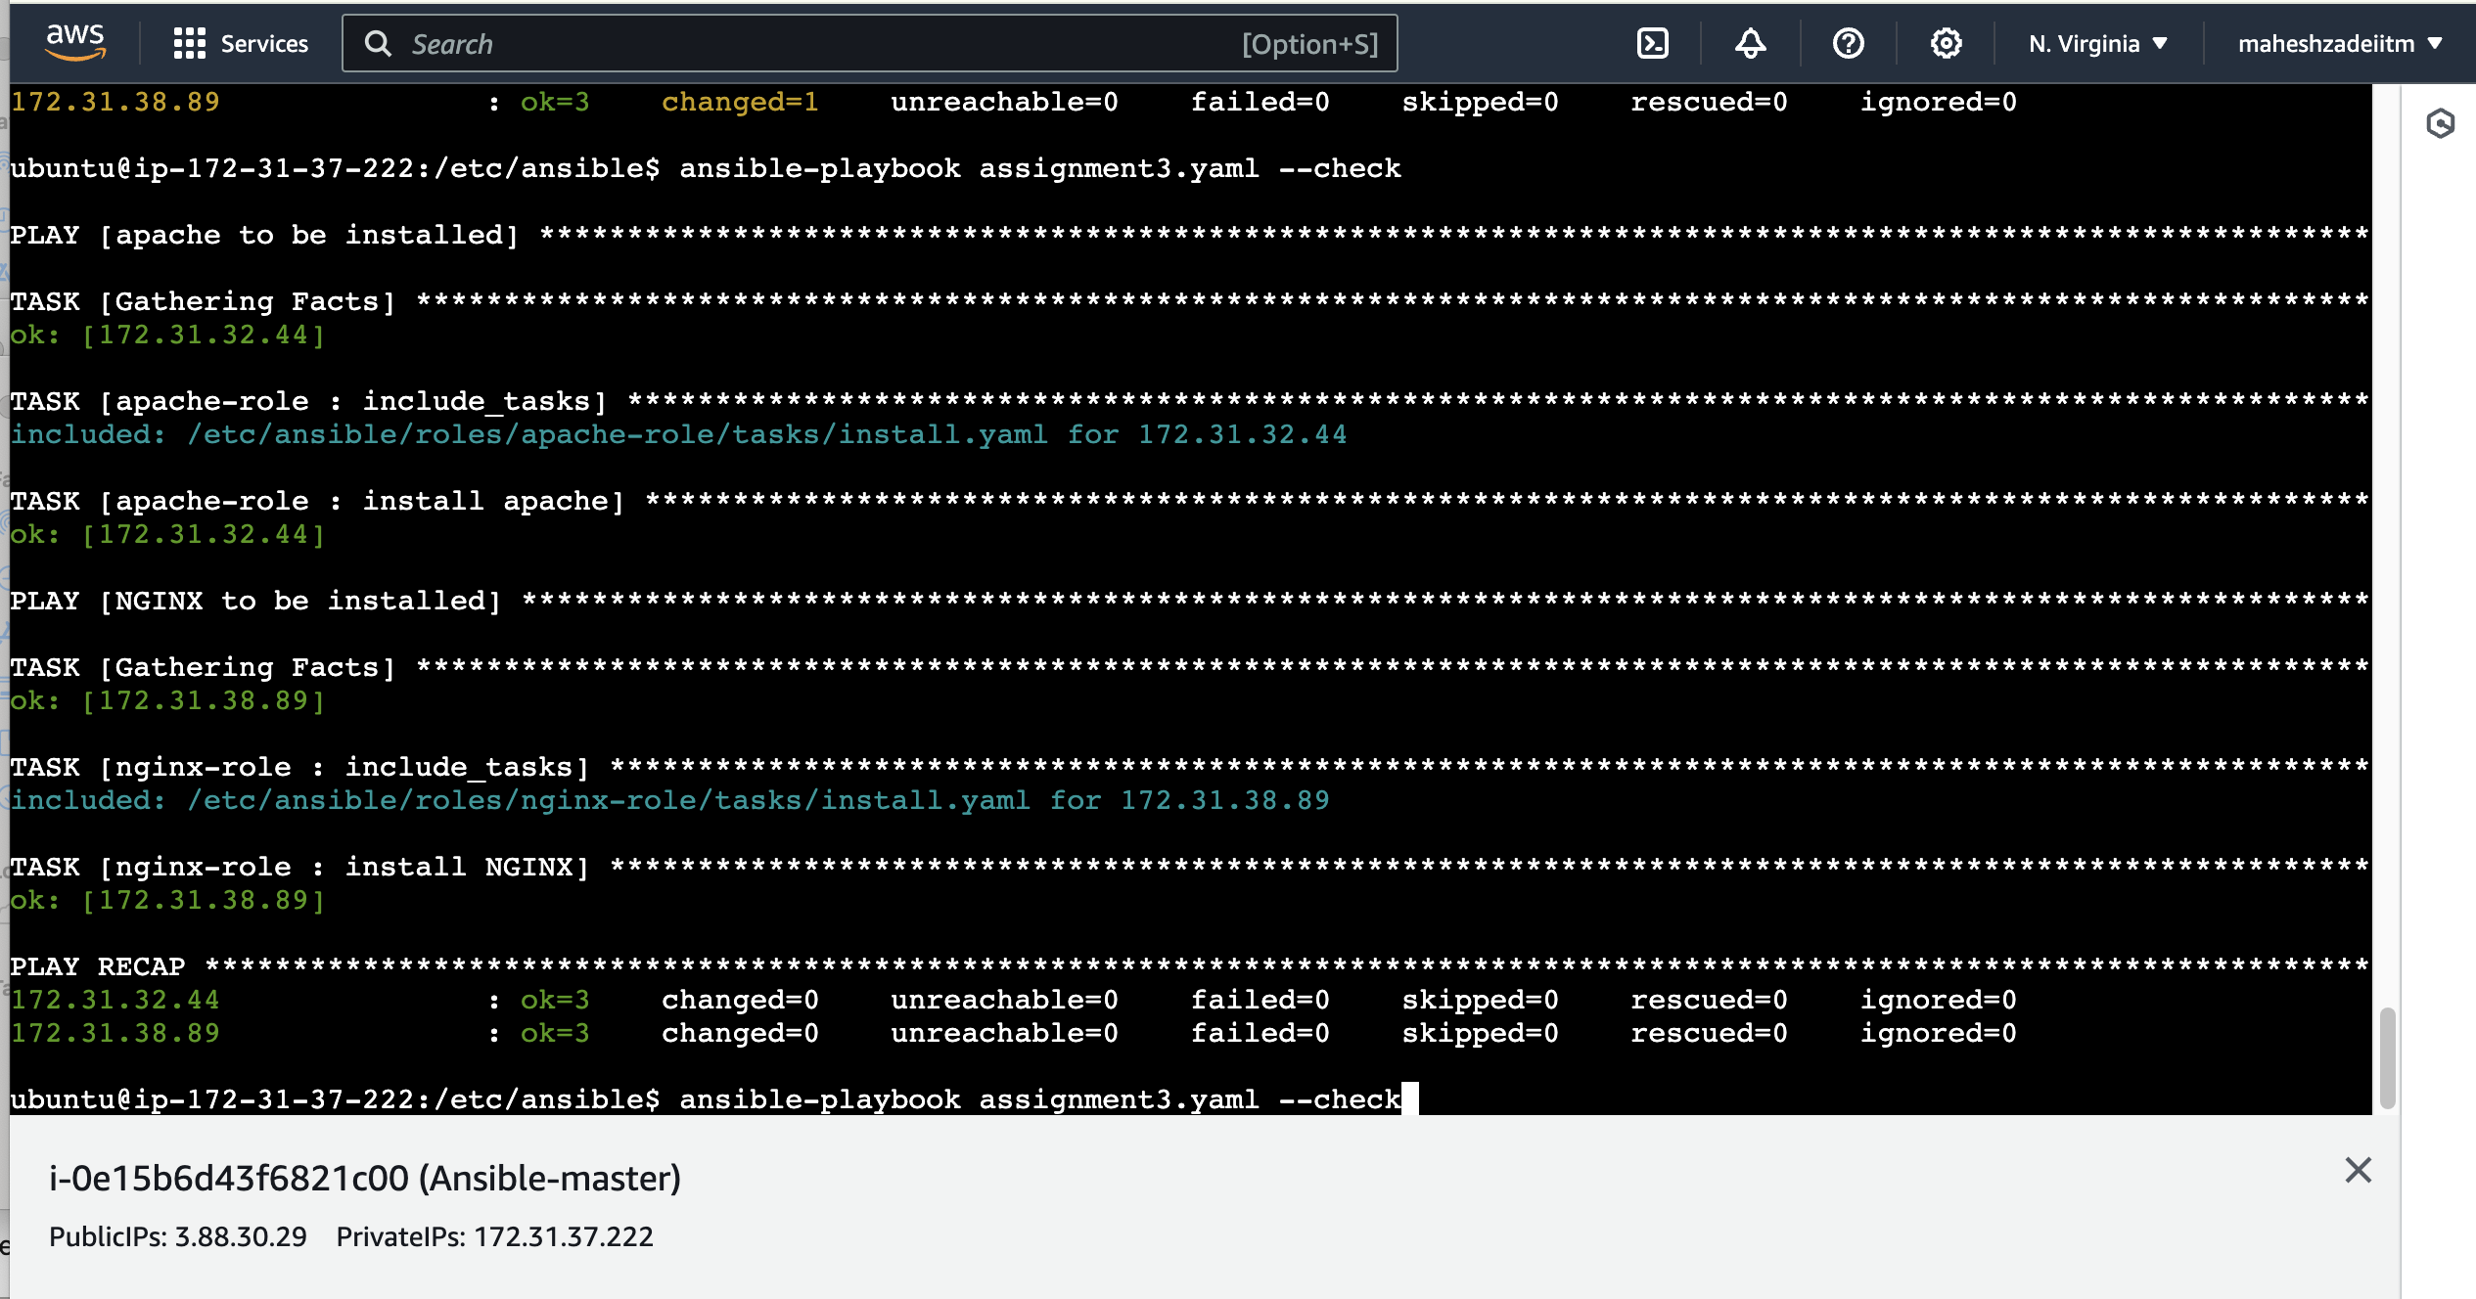

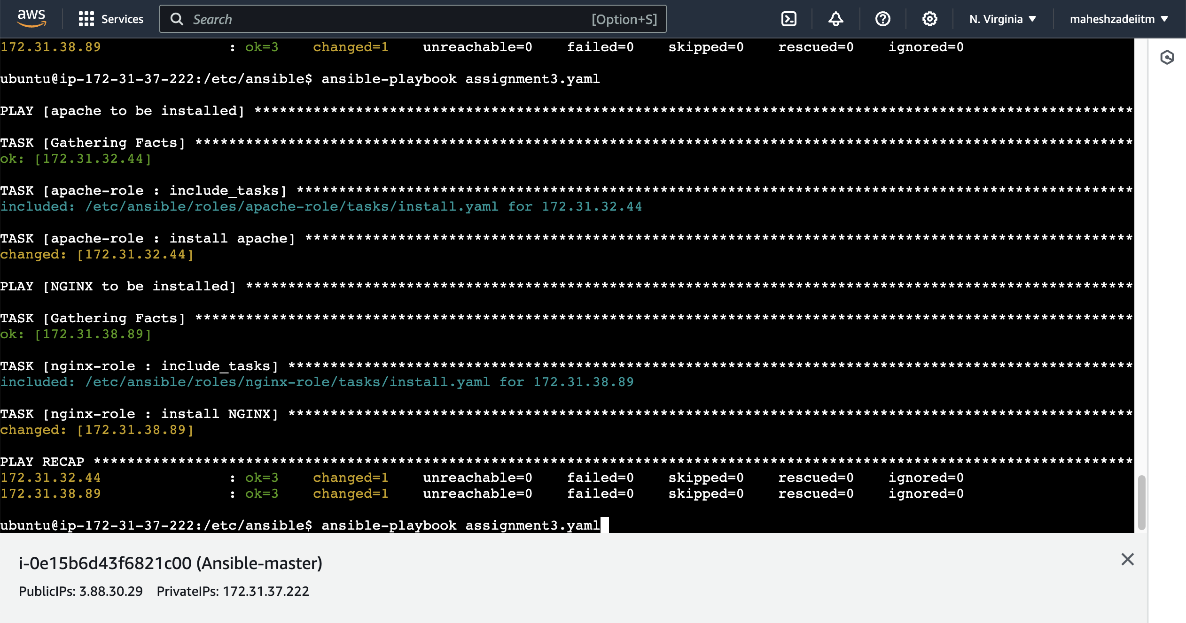

Now check in slave1 EC2 apache is installaed or not

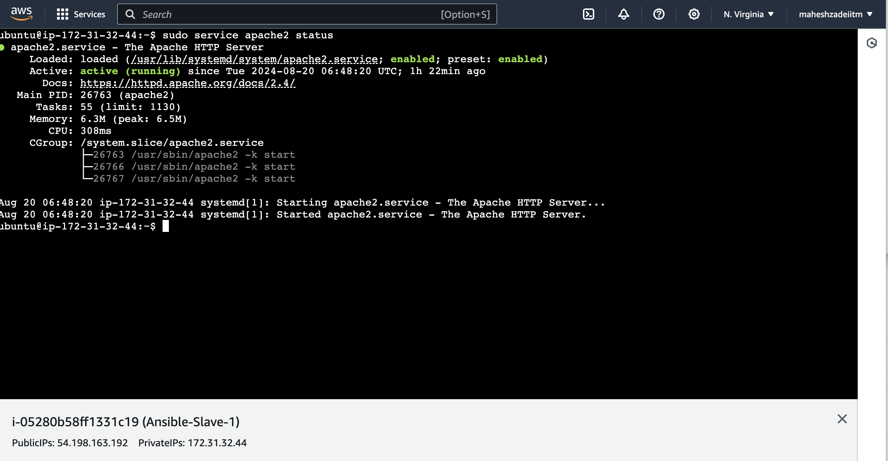

Apache installed

Check in browser also by copy public IP address of slae1 node

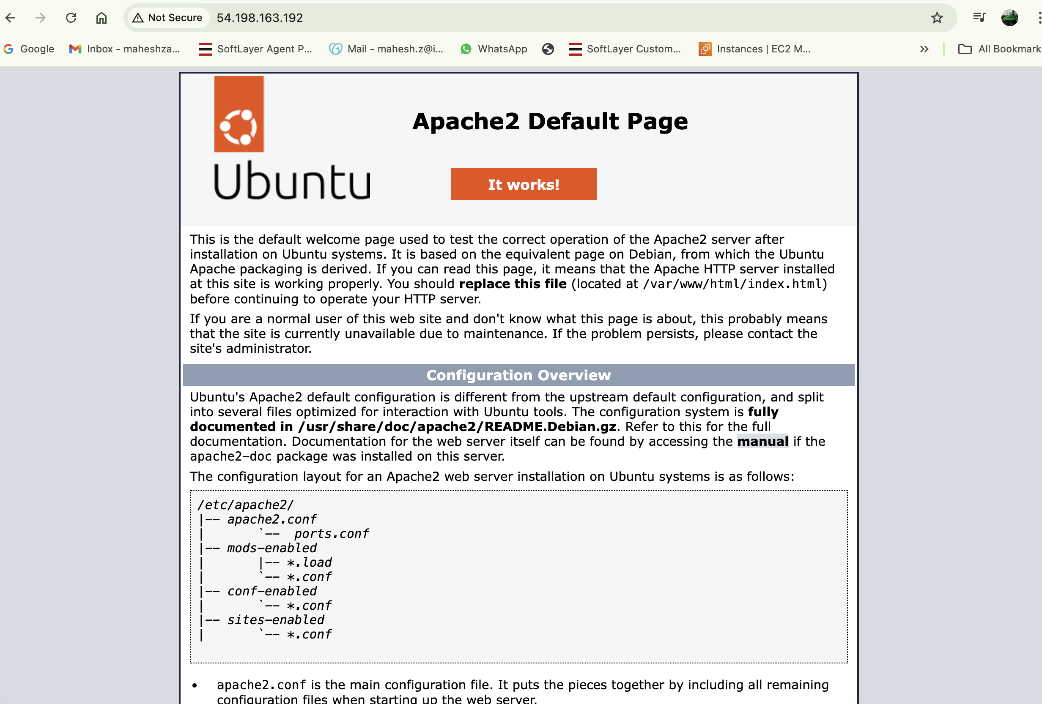

Working now

Now check nginx is installed in slave 2



It working now

Thanks

Thanks

Mahesh